1. Title will be very precise and crisp.
2. Good Abstract not include any results before implementation.
3. Keywords
4. Pictorial Representation of the Methodology.
5. Create the GANTT chart. Flow chart if needed.
6. Add cost for the components.
7. 15 to 20 slides.
8. Presentation duration is 10 to 15 minutes.

1. AI-Driven Crop Disease Prediction and Management System.

2. Sustainable Fertilizer Usage Optimizer for Higher Yield.

3. Al based acoustic wave monitoring of rail defects like cracks, fracture and prediction for rail wear, quality along with another parameter.

• "Smart AI System for Crop Disease Prediction"

• "AI-Driven Crop Health Diagnosis & Control"

• "Precision Agriculture: AI for Disease Management"

• "AI-Powered Crop Protection System"

• "Intelligent Crop Disease Monitoring & Management"

• "AI-Based Early Detection of Crop Diseases"

• "Smart Farming: AI for Disease Prediction"

• "AI-Driven Solutions for Crop Disease Control"

• "Next-Gen Crop Health with AI"

• "AI in Agriculture: Disease Prediction & Mitigation"

Railway

Railroad inspection has traditionally been a manual process with inspectors walking the track or driving slowly in a high-rail vehicle to visually spot problems. This practice is very costly, time consuming, impacts schedule performance (due to the need for track possession), and puts staff at risk. While there have been some recent attempts to modernize the inspection process through the adoption of machine-vision technologies, these technologies are often still reliant on human inspectors manually reviewing images in order to spot defects. Manual review of images suffers from many of the same problems as manual inspections do: it is time consuming, subjective as opposed to being objective, and requires significant amounts of labor. This paper builds on prior work to develop a Deep Neural Network that can automatically identify key railway components as a step in the process of automating rail inspection in an effort to overcome the limitations of traditional methods. This new study adds the identification of new railway components (Tie Plates) as well as the automated assessment of their condition.

This paper will explore a new approach that has the potential to overcome these limitations using Deep Learning algorithms, specifically a Deep Neural Network (DNN), to automatically inspect 3D Laser Triangulation images.

3D laser triangulation captures a both a high-resolution image (2D) and a 3D point cloud of the entire track area and can be used at revenue speeds, day or night.

DNN is a type of machine learning wherein the computer develops a solution to a complex problem in a way that is similar to how humans learn (using a neural network). Deep Learning is well-suited to image analysis and has even been demonstrated to improve the accuracy of cancer detection by oncologists when used to analyze images of lymph nodes.

The algorithm development process involved the use of a dataset of 400 images containing both

cancerous and non-cancerous cells (identified by a pathologist). Of the 400 images 270 were used for

algorithm training purposes and the remaining 130 were used to test the resulting algorithms. During the

training process slide images were combined with ground truth data in order to create both positive and

negative, 256 x 256 pixel, sample images which were used to teach the DL algorithm how to distinguish

between cancerous and non-cancerous cells. Following the training process the DL algorithm was tested

against the 130 test images in order to determine algorithm performance (Figure 2 - Framework of Cancer

Metastases Detection).



Framework of Cancer Metastases Detection

Applying Deep Learning to Railway Inspection

3.1 Inspection Challenges in the Railway Industry

Railway networks around the world represent billions of dollars of investment. Poorly maintained networks negatively impact asset longevity, schedule performance and pose a serious threat to safety. In order to safeguard against these risks, Railroads typically inspect on hundred (100) percent of their mainline network at least annually, and key locations even more frequently.

However, aside from the use of rail geometry measurement cars, the average railroad inspection is largely a manual process with inspectors walking the track or driving slowly in a high-rail vehicle to visually spot problems. This practice is very costly, time consuming, impacts schedule performance (due to the need for possession), and puts staff at risk.

In contrast, modern image-based approaches to railway inspection seek to create a permanent visual record of railway conditions which can be subsequently analyzed by trained inspectors from the comfort and safety of an office environment. Inspectors are trained to spot potential problems in the railway network visually, including: rail surface damage, damaged crossties (sleepers) and missing fasteners.

However, the task is not an easy one as rail networks are typically not homogenous in nature and can contain a wide variety of rail types and weights, fastener types and configurations, crosstie materials and conditions, special track work, and other elements which the inspector must identify and evaluate.

While there are indeed a great many advantages to the use of human expertise for visual inspection, there are also a number of challenges. Key among them is the subjective nature of human inspection in terms of data quality with no two inspectors “seeing” the same railway condition in exactly the same way. Compounding this problem is the repetitive nature of the task which tends to lower inspector performance as their working shift progresses. Lastly there is the impact of both personal and professional pressures on the quality of results from factors such as work deadlines, personal health, etc.

In recent years the industry has responded to this challenge by attempting to develop computer-based image processing techniques to supplement or replace the efforts of human inspectors. Invariably these approaches involve ML techniques which rely upon the designer defining the elements which the computer algorithm should identify. While some successes have been realized using this approach, the complex nature of the railway environment makes it very difficult to program for all instances.

DL has the potential to address the short comings of both human-based inspection and ML-based inspection by leveraging the best qualities of both approaches. Much in the same way that DL has shown potential to assist pathologists with the challenging task of image analysis in the medical field, the authors believe that inspectors in the railway industry can be likewise benefit from the power of DL.

High-Level Approach

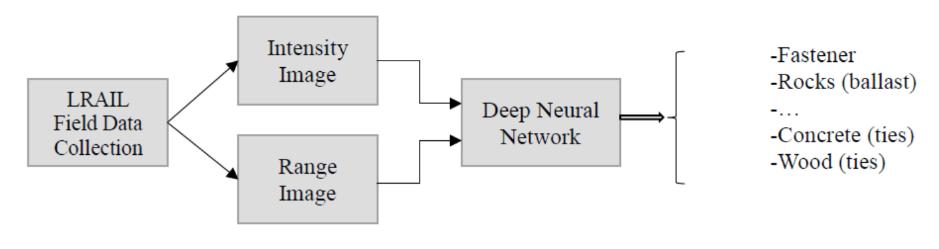

Image Capture Equipment

Pavemetrics’ Laser Rail Inspection System (LRAIL) was used for image capture. The LRAIL is a 3D Laser Triangulation sensor which combines pulsed high-power invisible laser line projectors, custom filters, and synchronized cameras to capture a high-resolution intensity image and 3D range profile of the railway trackbed. Laser light is used to illuminate railway surfaces and high-speed cameras are used to capture images of the projected light including its intensity and 3D shape (Figure 4 - Laser Triangulation Principle of Operation).

Figure

Laser Triangulation Principle of Operation 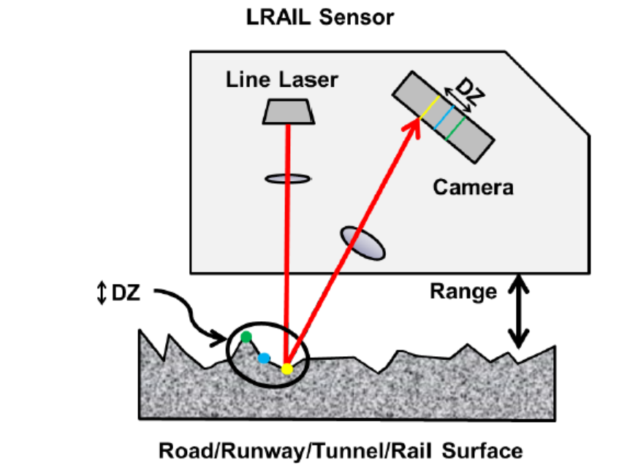

Laser Triangulation Principle of Operation



Intensity Image



Range Image



1mm by 1mm Scan of Railway



Motion Compensation

As the high-rail vehicle traverses the track there is a great deal of vehicle vibration due to track conditions and features which would otherwise create distortions in 2D and 3D data preventing subsequent analysis. To overcome this challenge inertial sensors are incorporated into each laser head in order to track pitch, roll and heading (inertial) for each sensor while the inspection vehicle is in motion. These data are

processed by specialized algorithms in order to remove their effect on captured scans (Figure 11 -

Correction for Vehicle Motion).



Correction for Vehicle Motion

Image Classification Algorithm Details (Prior Work)

The image classification algorithm developed in prior work is a seven layer (6 hidden layers and 1 output

layer) Supervised Machine Learning (SML) algorithm based on DeepCNet which combines 62,040

weights and 76 biases for a total of 62,116 learnable parameters (Figure 12 - DNN Diagram).

The six hidden layers include: a 5x5 convolution layer with 5 maps, a 3x3 semi-stochastic pooling layer, a

1x1 inception layer, a 5x5 convolution with 10 maps, and a 2x2 semi-stochastic pooling layer that outputs

to a fully connected output layer using softmax.

In order to determine if an image contains a fastener, some ballast, a concrete tie or a wooden tie, the

DNN first divides each 4,000 pixel x 2,000 pixel image into two 35 x 35 pixel sub-images. Each 35 x 35 pixel image (increased to 151 x 151 in present work) is then labeled by the algorithm as either “fastener,” “ballast,” “wood,” or “concrete” thus creating a “raw labeled” image.

Finally, the DNN groups sub images together in order to form regions which correspond to identified railway components (Figure 13 - Illustration of Processing Steps). This is used to eliminate small errors in sub image identification.



DNN Diagram



Illustration of Processing Steps

Tie Plate Identification and Acceptability Rating Algorithm

Building on previous work, the DNN’s Image Classification Algorithm was further trained to permit it to also identify tie plates (Figure 14 - DNN Identification of a Tie Plate) and a second phase of analysis was introduced in order to rate their acceptability (Figure 15 – DNN Tie Plate Rating).



DNN Identification of a Tie Plate



DNN Tie Plate Rating



Fastener Classification Example

Tie Plate Rating Algorithm Training Process

For the Tie Plate Rating algorithm, a total of 2,852 images of acceptable tie plates and 82 images of faulty tie plates (twisted, shifted or hanging) were used for training and a matching set for testing. While it would have been ideal to utilize similar numbers of acceptable and faulty tie plates for training and testing purposes, this was not practical given the normal rate of occurrence of faulty tie plates for properly maintained track.

3.9 Algorithm Performance Testing

Once the training process was completed, the DNN was applied to the test dataset which consisted of images not prior presented to the DNN during training in order to evaluate performance using novel cases.

The performance of the Component Identification Algorithm was excellent; errors in the correct identification of components were below 1% for all component types (Table 2 – Component Identification Algorithm Performance).

Enhanced DNN Layer Details

151x151 input layer (3D railway scans)

•

5x5 convolution layer with 8 maps

•

3x3 semi-stochastic pooling layer

•

1x1 inception layer

•

5x5 convolution with 32 maps

•

5x5 convolution with 64 maps

•

2x2 semi-stochastic pooling layer

•

Fully connected output layer using SoftMax











Training and Testing a Neural Network



Present data to AI + give it the correct answer

•

Then test its ability to obtain correct answer for new data

•

Repeat process until no further gains are made (“convergence”)

•

One full cycle through data is called an “Epoch”

•

DNN error (difference between expected and actual classification) is calculated for each Epoch in order to adjust parameter weighting

•

It usually requires at least 50 Epochs to train an AI

Fastener Identification Example



Adding Component Condition Analysis



Tie Plate Inspection

Once tie plates are automatically identified by the DDN their condition can be assessed

•

The DNN was trained to flag tie plates which do not match a typical or “acceptable” installation

•

Faulty tie plates are those which are twisted, shifted left or right or “hanging” compared to the adjacent rail



1. Title
2. Problem Statement with major challenges
3. Abstract
4. Background (Current Scenario) and challenges
5. Objectives
6. Methodology (with hardware)
7. Outline of Methodology
8. Key Features
9. Technologies and Tools
10. Cost Split up
11. Phases of Project